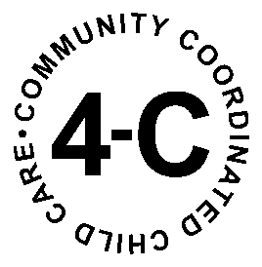

CHILD AND ADULT CARE FOOD PROGRAM
CONTACT FORM

To begin the enrollment process or to learn more about the 4-C Food Program and how the program can benefit your family child care business, please call: 815-758-8149, ext. 234 or 800-848-88727, ext. 234, email: suew@four-c.org or FAX: 815-758-5652 the following information:

Name: ______________________________________________________

Address: ____________________________________________________

City/State/Zip: _______________________________________________

Email: ______________________________________________________

Answering the following questions is helpful, but not required:

- Are there children under the age of 13 living in your home?

- Is your family child care home business currently licensed by IL Department of Children and Family Services (DCFS)?

- Are you currently providing care for children in your own home who do not live with you?

Thanks for your interest in the 4-C Food Program. We look forward to hearing from you soon!
Once we receive your information, please know you’ll hear from US soon!

Sincerely,
Child and Adult Care Food Program Staff

