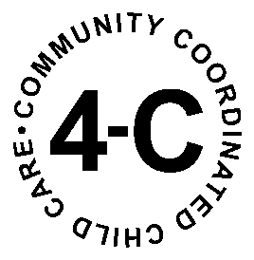

CHILD AND ADULT CARE FOOD PROGRAM
DIRECT DEPOSIT FORM

If you would like your Food Program reimbursement deposited directly into your personal financial account, please complete this form and mail it to 4-C, 155 N 3rd St, Suite 300,
DeKalb IL 60115.

Name on account: ______________________________________________________

Business name (if applicable______________________________________________

Account Type (circle one): Checking Savings

Bank Routing Number (9 numbers starting from far left of check):

______________________________________________________

Bank Account Number (Next series of numbers):

______________________________________________________

Please attach a copy of a voided check (for checking), or a statement from the bank (for savings –as routing numbers are not typically included on deposit/withdrawal slips for savings accounts).

Sincerely,
Child and Adult Care Food Program Staff

